‘What’s new with model 2?’
Changes in the calculation of treatment results with implementation of WEEE Directive 2012

With 24th July 2012 the WEEE Directive 2012 has been published in the Official Journal of the European Union and shall be implemented by the member states until February 2014.
Looking for the relevant topics regarding the determination and calculation of treatment results the main ‘new issues’ are:
- Definitions regarding treatment like ‘re-use’, ‘treatment’, ‘recovery’, ‘preparing for re-use’, ‘recycling’ and ‘disposal’ are given by reference to the Waste Framework Directive 2008 (short as WFD 2008) Article 3 (see WEEE Dir. Article 3, point 2). There are no internal, ‘own’ definition regarding treatment within the WEEE Directive anymore.
- There are new recycling and recovery targets set distinguishing different periods of application with different targets set (see Article 11 referring to Annex V) (see page 4 of this document).

Executive summary on changes:

Based on the more stricter definition of ‘recycling’ we changed the WF-classification for
- waste fractions used as reducing agent but not reprocessed into products - relevant for:
- plastics used as reducing agent in e.g. steel mills (C as C02 emission)
- metals used as reducing agent but slag not classified as by-product or as defined product (metal oxides to slag → slag not by-product or defined product)
- waste fractions (e.g. glass) used as slag forming component but no definite use of slag – relevant for:
- Cu smelter - slag not classified as by-product slag or used as defined product
- Pb smelter - slag as waste for landfill disposal
- use of volume and/or physical properties of waste fractions like
- as unspecified construction material for dams, for fills and filling of shafts
- as cover material at landfill sites
- for driveway construction at landfill sites
All of these applications and ‘backfilling’ do meet the requirements of the definition of ‘recovery’ as wastes are used for a useful purpose and do fulfil a particular function. Therefore we classified these uses/applications as OMR = ‘other material recovery’, a classification which will count to the ‘recovery rate’ but not to the ‘recycling rate’.

Regarding recycling & recovery targets the main change is that from period 2 of the WEEE Dir. 2012 (from Aug. 2015) the preparing for re-use shall be added to the prepared for re-use and recycling rate. With this the preparing for re-use of whole appliances may be added to total results.

Background information

The main difference in the definitions lays in the definition of ‘recycling’.
In the ‘old’ WEEE Directive 2002/96/EC ‘recycling’ was defined as:
- ‘recycling’ means the reprocessing in a production process of the waste materials for the original purpose or for other purposes, but excluding energy recovery which means the use of combustible waste as a means of generating energy through direct incineration with or without other waste but with recovery of the heat;

In the ‘new’ WEEE Directive 2012/19/EU reference is given to the WFD 2008, Article 3 (17) where ‘recycling’ is defined as:
- 'recycling' means any recovery operation by which waste materials are reprocessed into products, materials or substances whether for the original or other purposes. It includes the reprocessing of organic material but does not include energy recovery and the reprocessing into materials that are to be used as fuels or for backfilling operations;

- We understand the ‘new’ definition of ‘recycling’ in that way that products, materials or substances have to be achieved with the waste applied.

The guidance document on the WFD 2008 provides explanations of the term ‘recycling’ (see point 1.4.6, original wording) as:
- The common idea behind recycling is that a waste material is processed in order to alter its physico-chemical properties allowing it to be used again for the same or other applications.
- Recycling includes any physical, chemical or biological treatment leading to a material which is no longer a waste. Article 3 (17) WFD does not require any particular characterisation of the processing or reprocessing activity, as long as it serves the objective of generating a material which is used for the original or for other purposes, and thus of closing the economic material circle. Consequently, the reprocessing into materials that are to be used as fuels or for backfilling operations is excluded from recycling (and, in terms of the WFD, represent ‘other recovery’ – see next point).
- It follows from the WFD recycling definition that only the reprocessing of waste into products, materials or substances can be accepted as recycling. Processing of waste which still results in a waste which subsequently undergoes other waste recovery steps would not be considered recycling, but pre-treatment prior to further recovery ...

- This means that applications of wastes where this waste does not end up in a defined product for a defined application will not be classified as ‘recycling’.

Based on this there was the need to update the classification of some uses of wastes / components in the WF-classification of the WF-RepTool. Most relevant examples where ‘recycling’ is not achieved are:

- Material(s) used as reducing agent but not reprocessed into products e.g.
- plastics [and organic residues in (components of) fractions] used as reducing agent in e.g. steel mills (C of plastics → C0₂ → C0₂ emission)
- metals used as reducing agent (or ‘smelting detergent) but slag not classified as by-product or used as defined product for use (metal → metal oxides → metal oxides transferred to slag → slag not by-product or defined product)
- Material(s) (e.g. glass) used for feedstock substitution as slag forming component but no definite use of slag e.g.
- Cu smelter - slag not classified as by-product slag or used as defined product for use
- Pb smelter - slag as waste for landfill disposal
- Material(s) use of volume and/or physical properties in other construction purposes than road construction (here defined products as requirement) and defined construction purposes (here defined product qualities as requirement) e.g.
- as unspecified construction material for dams, for fills and filling of shafts
- as cover material at landfill sites
- for driveway construction at landfill sites
Table 1: Needs to change classification as ‘recycling’

The use of waste materials for ‘backfilling operations’ is excluded from the classification as ‘recycling’ by definition – see box at page 2: ... but does not include ... backfilling operations;

All applications mentioned in Table 1 and ‘backfilling’ do meet the requirements of the definition of ‘recovery’ (see WFD 2008, Article 3 (15)) as following:
- ‘recovery’ means any operation the principal result of which is waste serving a useful purpose by replacing other materials which would otherwise have been used to fulfil a particular function, or waste being prepared to fulfil that function, in the plant or in the wider economy. Annex II sets out a non-exhaustive list of recovery operations;
... as wastes are used for a useful purpose and do fulfil a particular function.

The WFD 2008 does not provide a definition for backfilling. For this Article 1 (6) of Commission Decision establishing rules and calculation methods ... provides more information as it is stated that:
- ‘backfilling’ means a recovery operation where suitable waste is used for reclamation purposes in excavated areas or for engineering purposes in landscaping and where the waste is a substitute for non-waste materials’.

Remark: It should be stressed that one of the conditions of this definition of ‘backfilling’ is that the operation concerned meets the recovery definition of Article 3(15) WFD, which has to be assessed depending on the specific circumstances of the operation planned. The fact that an operation is referred to as ‘backfilling’ by the operator does not automatically make the operation a recovery operation.

In the WFD 2008 ‘backfilling’ is only further mentioned under the topic of construction and demolition waste (see Article 11(2) (b)) where it is mentioned under targets for ‘... other material recovery, including backfilling operations ...’.
We took this to subsume ‘backfilling’ under ‘other material recovery’

The guidance document on the WFD 2008 provides some information on What is meant by ‘other recovery‘? (see point 1.4.7) as:
- ‘Other recovery’ is any operation meeting the definition for ‘recovery’ under the WFD but failing to comply with the specific requirements for preparation for re-use or for recycling.
- Examples of other recovery operations are:
- Incineration or co-incineration where the principal use of the waste is as a fuel or other means to generate energy. It is a waste management operation with energy recovery, classified as R1 in Annex II to the WFD. ...;
- Backfilling operations meeting the recovery definition ...

- Based on all these information we classified applications which do not meet the requirements of the ‘recycling’ definition but which do meet the ‘recovery’ definition as the ‘interim classification’ of ‘other material recovery’ [see uses/applications in Table 2 at page 6, consider there is the classification of ‘energy recovery’ beside].

Some remarks may be given to Table 1:
- The guidance document on the WFD 2008 also provides the example that blast furnace slag from steel production may be considered a by-product and falls outside the definition of waste (see example in point 1.2.4) → based on this, materials used for and ending up in this or similar slag have been classified as recycling.
- ad 1a) The authors of ESWI^{I} proposed already in 2009 that with application of the WFD 2008 the use of plastics and/or organic shares of materials as reducing agents should not be considered as recycling. Within their project – see calculation of recycling efficiencies for the treatment of batteries – they already felt the strong opposition of operators of smelting technologies claiming that they use one of the best available technologies. The authors of the study stayed with their opinion.
- ad 1b) If metals are used as reducing agents and are transferred to slag and the slag is classified as by-product, this use/application will be classified as ‘recycling’.
- ad 2a) If slag will be classified as by-product (Cu smelter) or 2b) approved, defined products will be processed, this application/use will be classified as ‘recycling’.
- ad 3) The application/use of fractions under 'defined quality classes' as road construction material or for other defined construction purposes (e.g. draining layers) will be classified as ‘recycling’, see e.g. technical standards for the material have to be met.

We will calculate the ‘recycling rate’ only for/from application/uses classified as ‘recycling’ and we will calculate the ’recovery rate’ as:
’recovery rate’ = (preparing for re-use + recycling + other material recovery + energy recovery) /
input of material

Please have a look at Table 2, page 6 for applications/uses classified as OMR according to the WF-classification under model 2. You will see all WF-classifications like usual in your download version of the WF-classification or within the WF-RepTool choices.

Consider that you will still have the option for a ‘national classification’ to upgrade or downgrade any classification.

Regarding the question of calculating recycling and recovery results as ‘recycled’ or as ‘prepared for re-use and recycled’ – see targets given in the box below -

WEEE Directive 2012/19/EU:
ANNEX V defines 3 time periods for which different targets are set, whereby in
- time period 1 (until Aug. 2015) the targets are set as - example WEEE cat. 1 or 10 -
80 % shall be recovered, and
75 % shall be recycled;
- time period 2 (Aug. 2015 until Aug. 2018) the targets are set as - same example -
85 % shall be recovered, and
80 % shall be prepared for re-use and recycled;
- time period 3 (form Aug. 2018) other grouping of WEEE but also
85 % shall be recovered, and
80 % shall be prepared for re-use and recycled;

we skipped discussions according to which in period 1 of the ‘new’ WEEE Directive 2012/19/EU should be understood to be 'identical' with the ‘old’ WEEE Directive and only from period 2 onwards more ambitious targets e.g. including preparing for re-use of whole appliances should be achieved.
[According to ‘informal information’ the preparing for re-use of components has been simply forgotten for period1].

In the WF-RepTool detail results in columns and 3 lines of total results will be provided:
- Recycling rate
- Preparing for re-use and recycling rate (components and whole appliances)
- Recovery rate
These are the treatment rates as results. If targets set by the members states are met with or without calculating preparing for re-use of components can not be solved by the WF-RepTool. It is up to the WF-RepTool user to choose the results aggregated.
Annex

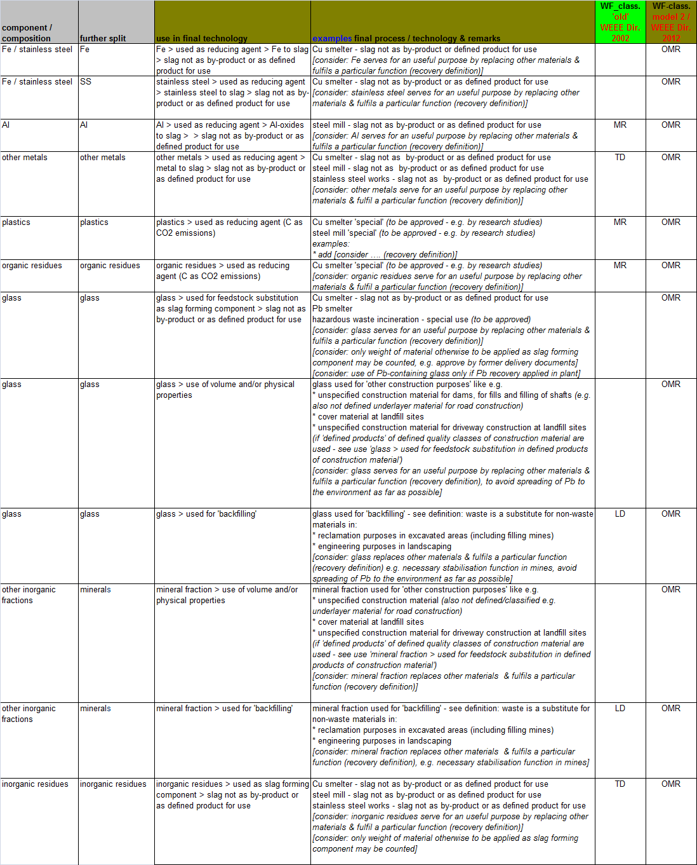
Table 2: Applications/uses classified as OMR

--------------- Disclaimer ---------------
The information contained in this document is part of WF-RepTool and exclusive property of the WEEE Forum. The information is provided without warranties (garantie) of any kind and is intended solely for the exclusive purpose of allowing authorized WF-RepTool users to report treatment results of Waste Electrical and Electronic Equipment in a uniform manner and to calculate recycling and recovery quotas achieved. Users are not allowed to display or print the information provided, except for their own, non-commercial, use. If you have received this information in error, please notify info@wf-reptool.org immediately and then destroy all electronic and physical copies.

OJ L 197, 24.7.2012, p. 38 - DIRECTIVE 2012/19/EU OF THE EUROPEAN PARLIAMENT AND OF THE COUNCIL of 4 July 2012 on waste electrical and electronic equipment (WEEE) (recast)
OJ L 312, 22.11.2008, p. 3 - DIRECTIVE 2008/98/EC OF THE EUROPEAN PARLIAMENT AND OF THE COUNCIL of 19 November 2008 on waste and repealing certain Directives, Article 3
see exemptions for road construction and defined construction purposes if defined products are achieved and used
Guidance on the interpretation of key provisions of Directive 2008/98/EC on waste, June 2012 - http://ec.europa.eu/environment/waste/framework/guidance.htm
we do not apply the ‚end-of-waste‘ criteria at present – see: leading to a material which is no longer a waste … – as end-of-waste will not be achieved by quite some waste materials from WEEE – e.g. criteria for plastics pending, CRT glass will not achieve end of waste requirements in most counties, ...
OJ L 310, 25.11.2011, p. 11 - COMMISSION DECISION of 18 November 2011 establishing rules and calculation methods for verifying compliance with the targets set in Article 11(2) of Directive 2008/98/EC of the European Parliament and of the Council (notified under document C(2011) 8165) (2011/753/EU)
[ESWI, 2009] Consortium ESWI - Expert Team to Support Waste Implementation - Study on the calculation of recycling efficiencies and implementation of export article (Art. 15) of the Batteries Directive 2006/66/EC, study on behalf of the European Commission, Brussels, Final Report, May 2009 http://ec.europa.eu/environment/waste/batteries/pdf/batteries090528_fin.pdf
see to calculate the (preparing for) re-use of components to the ‘re-use and recycling rate’ - see Definitions in WEEE Directive 2012/19/EU

